1. Select concat(last_name,’works in deptno ‘,department_id,’with the ‘ , job_id) from employees;

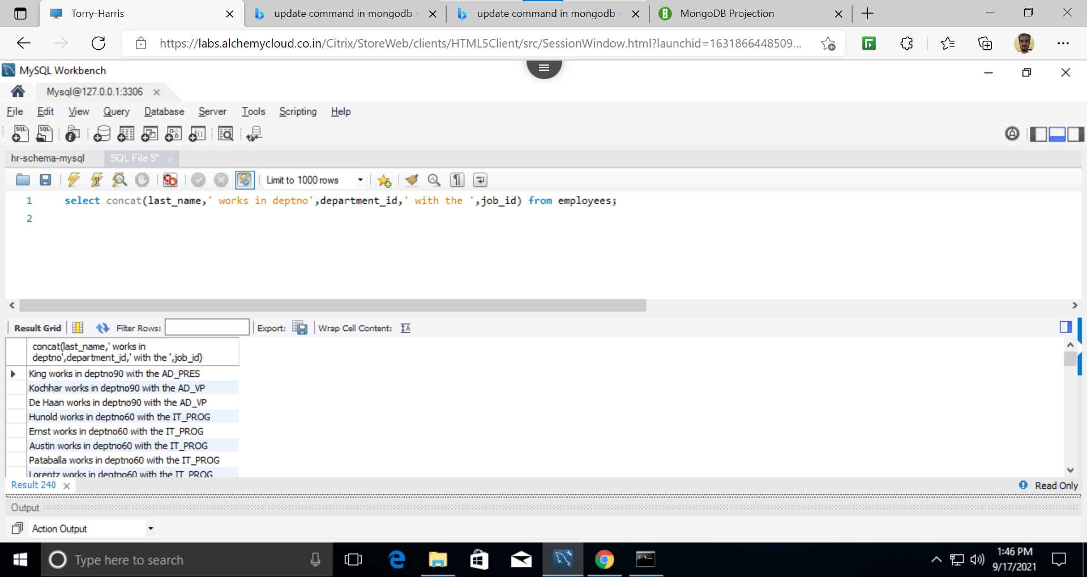

2. employees who joined in the year 2000

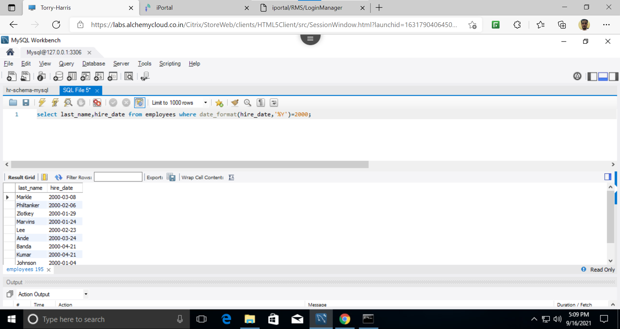

3. employees joined after jan_1996

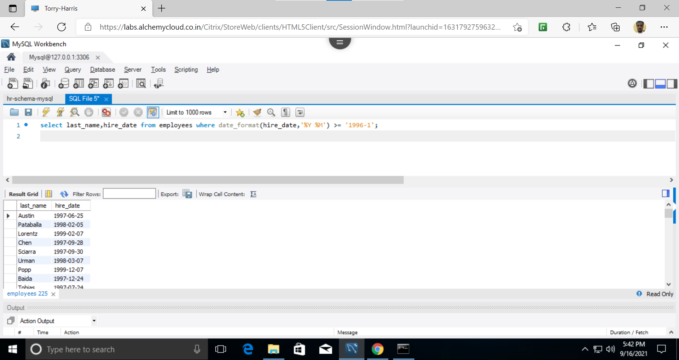

4.select last_name from employees where (last_name like ‘S%’) or (last_name like ‘R%’);

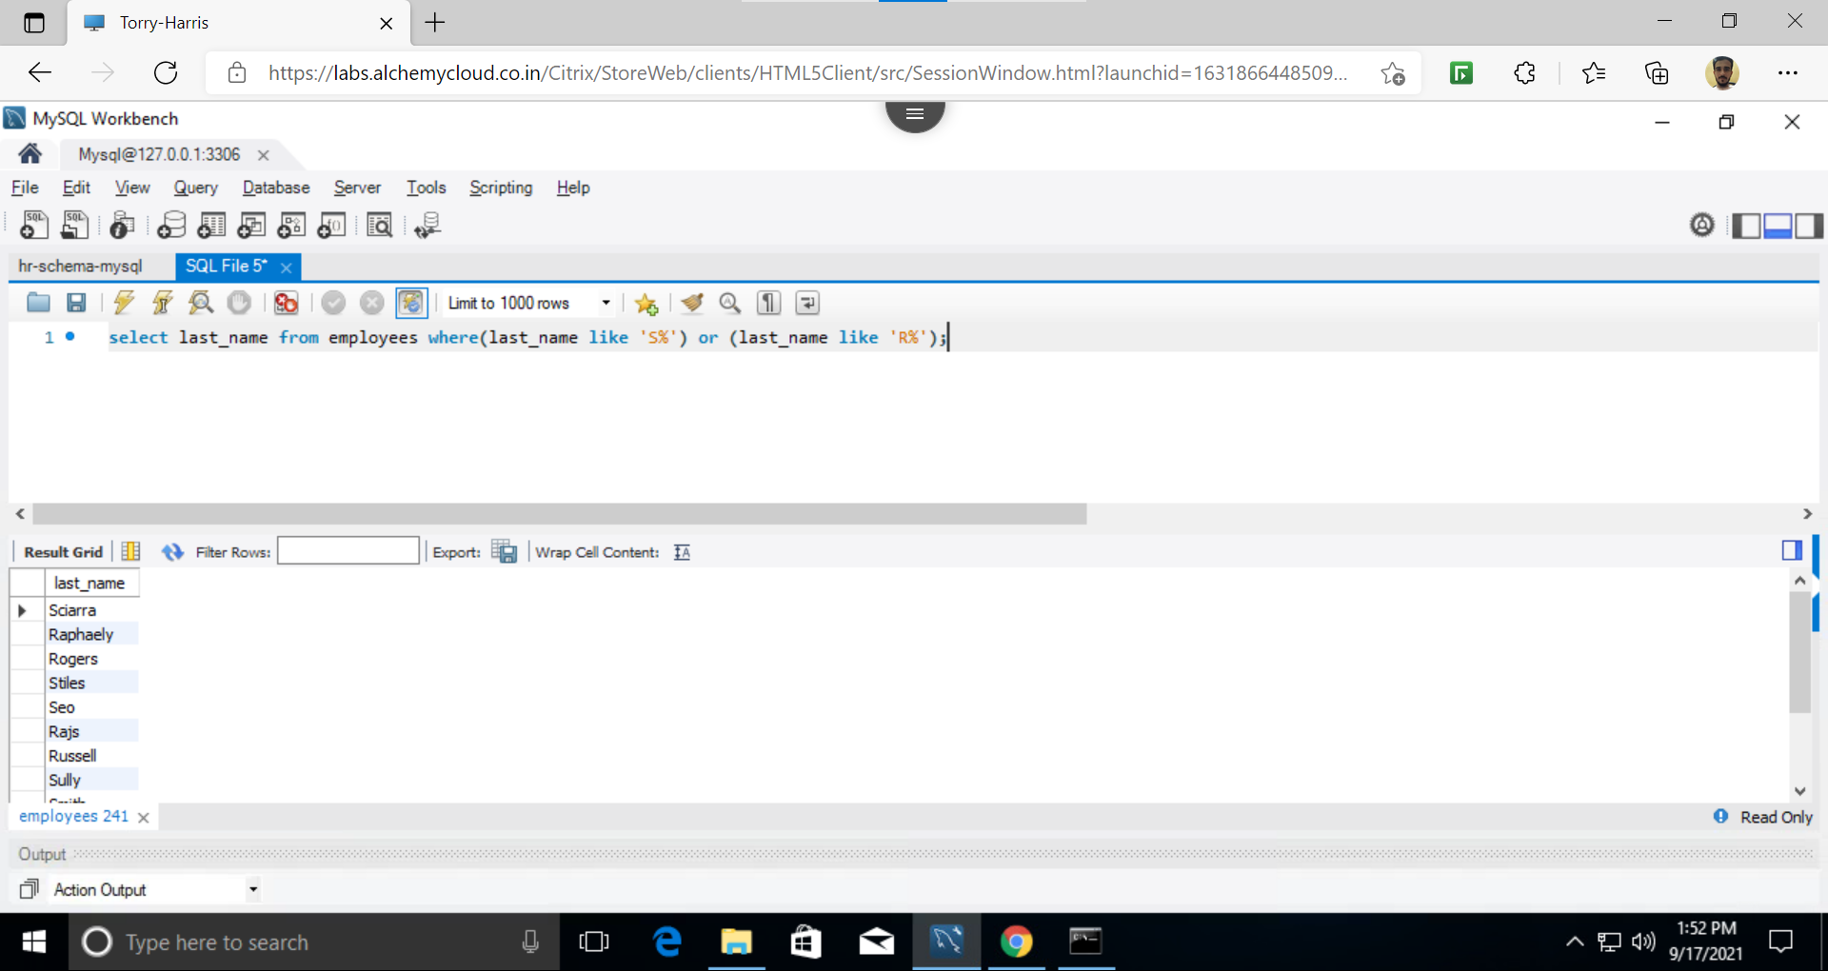

5. select * from employees where manager_id in (200,201);

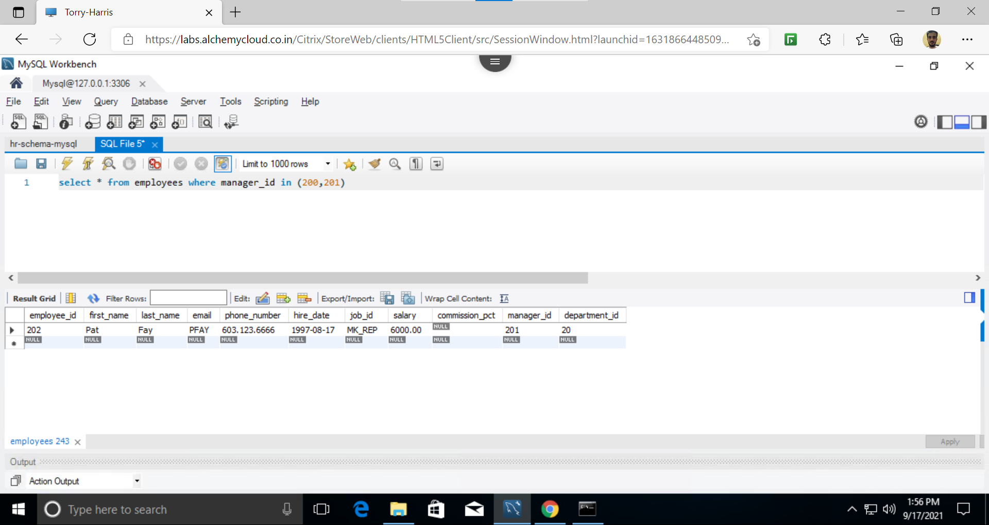

6. select employee-_id,last_name,first_name,job_id from employees where (job_id like “%MAN%” or job_id like “%REP%”) and salary>6000;

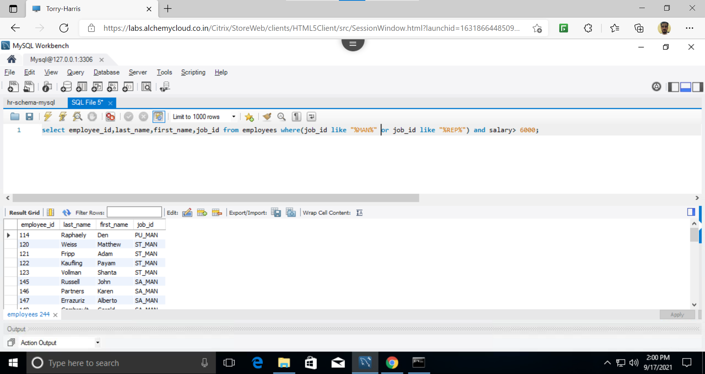

7.select salary,(salary*12) annualsal,from employees order by salary desc;

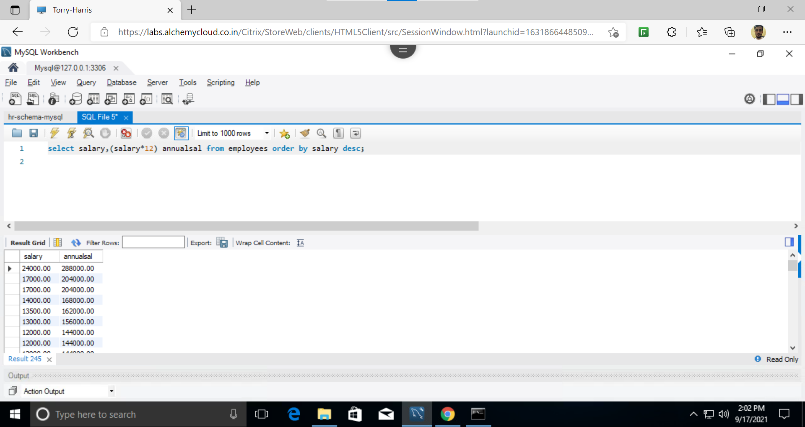

8. select last_name,replace(last_name,’landry’,’joe’) from employees where last_name=’landry

9.select last_name,instr(last_name,’o’) from employees;

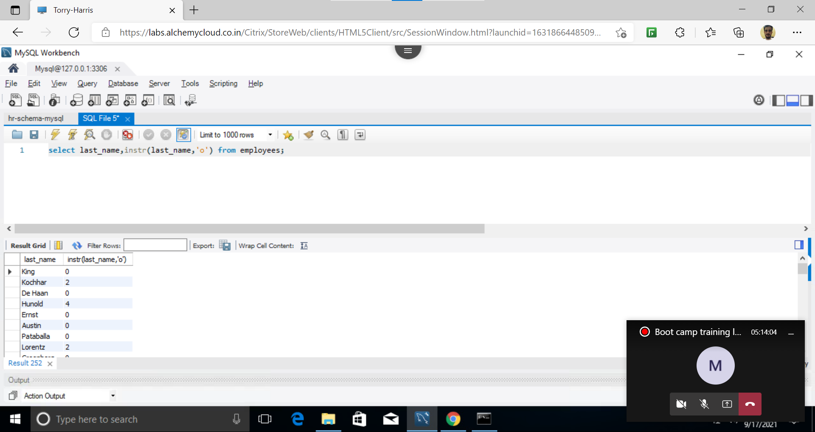

10. Select concat(‘2020_b84’,last_name) from employees where department_id=90;

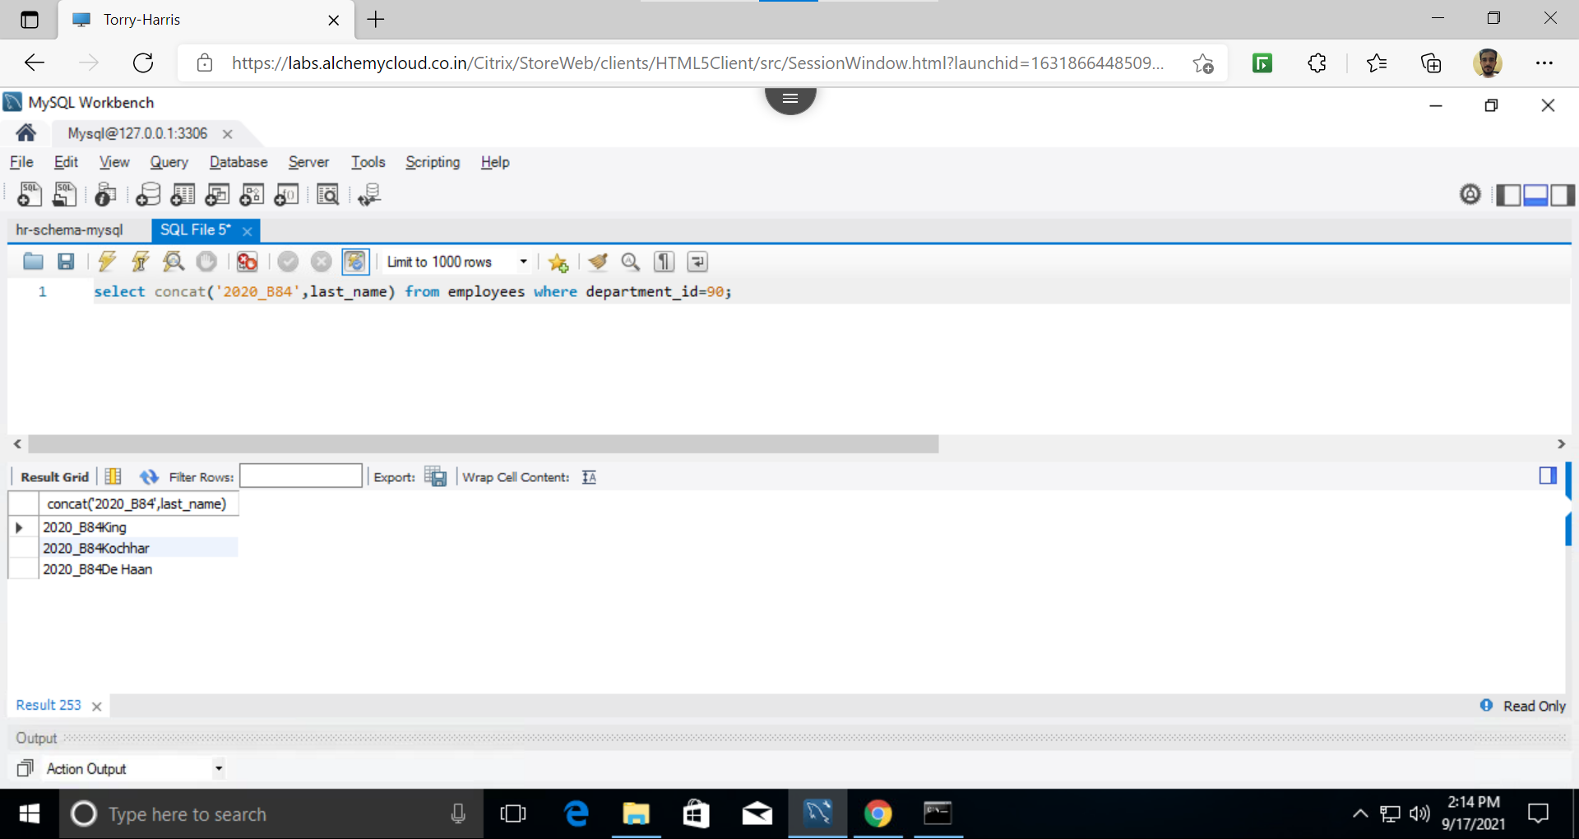

11.select current_timestamp();

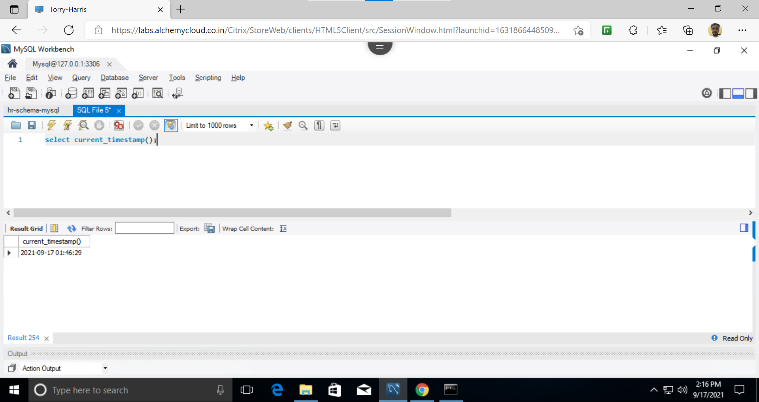

12. Select avg(commission_pct) from employees;

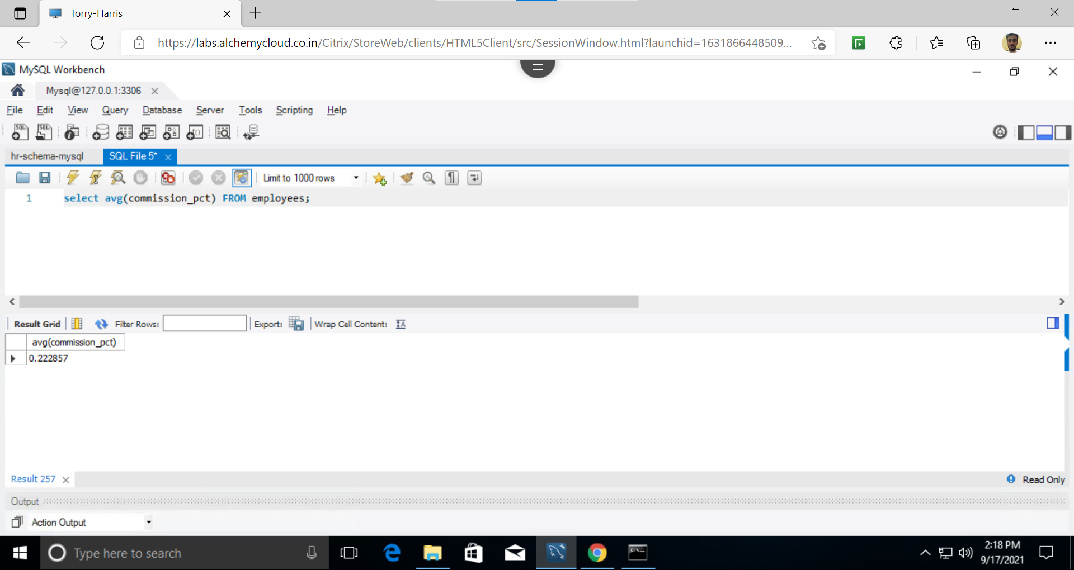

13. Select deprtment_id,max(salary),avg(salary) from employees group by department_id having department_id in (80,90,100);

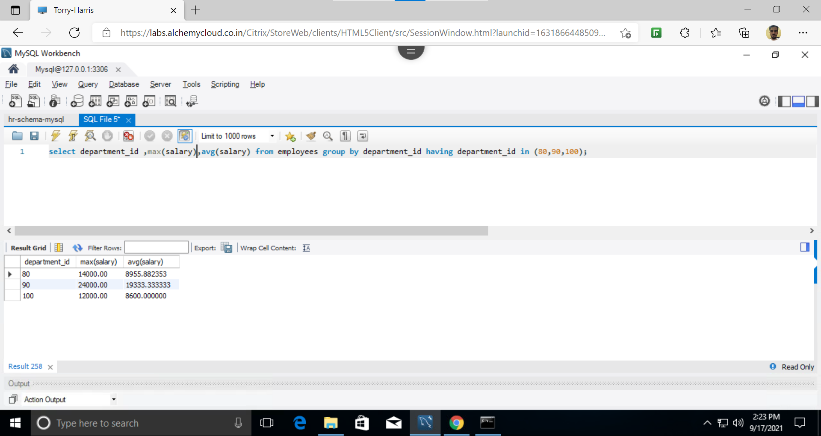

14.select department_id,max(salary) from employees group by department_id having max(salary)>1000;

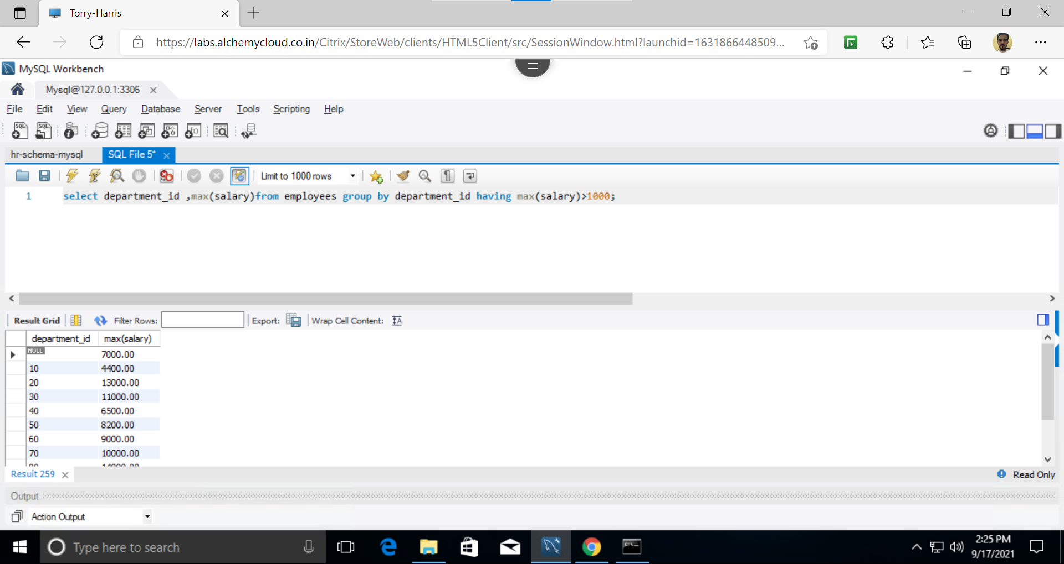

15.select max(sal) from (select avg(salary) as sal from employees group by department_id) as result;

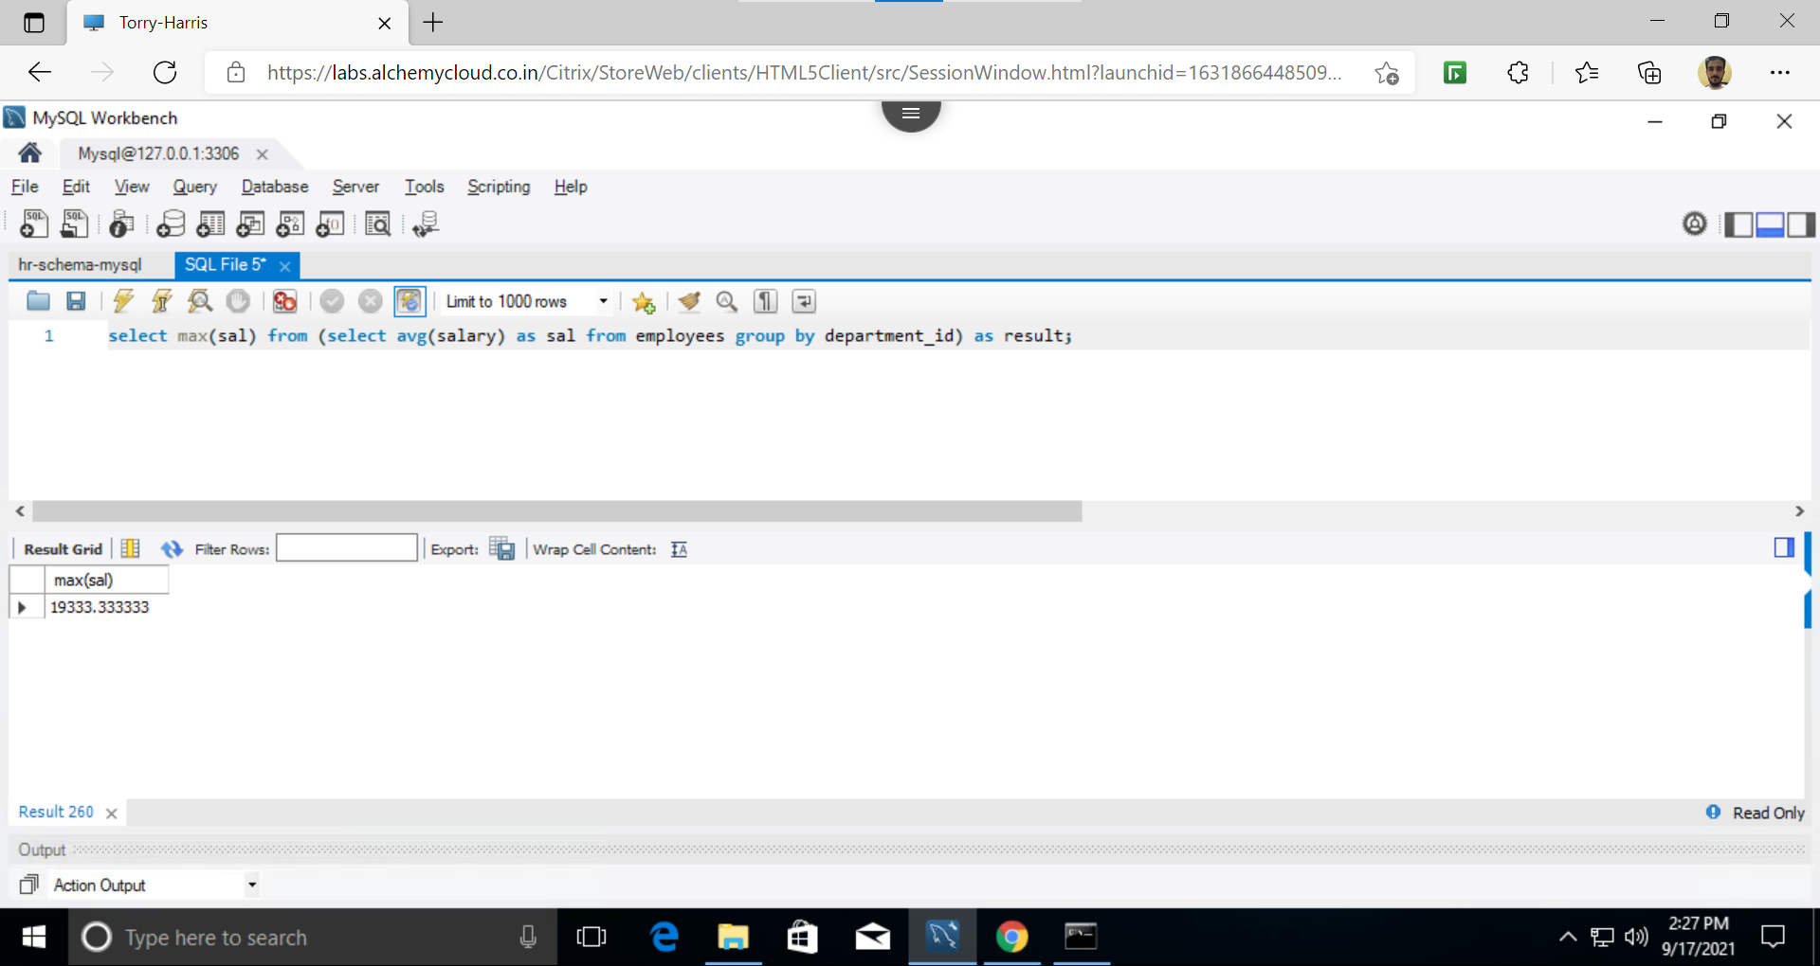

16. Select e.last_name,d.department_name,d.location_id from employees as e,departments as d;

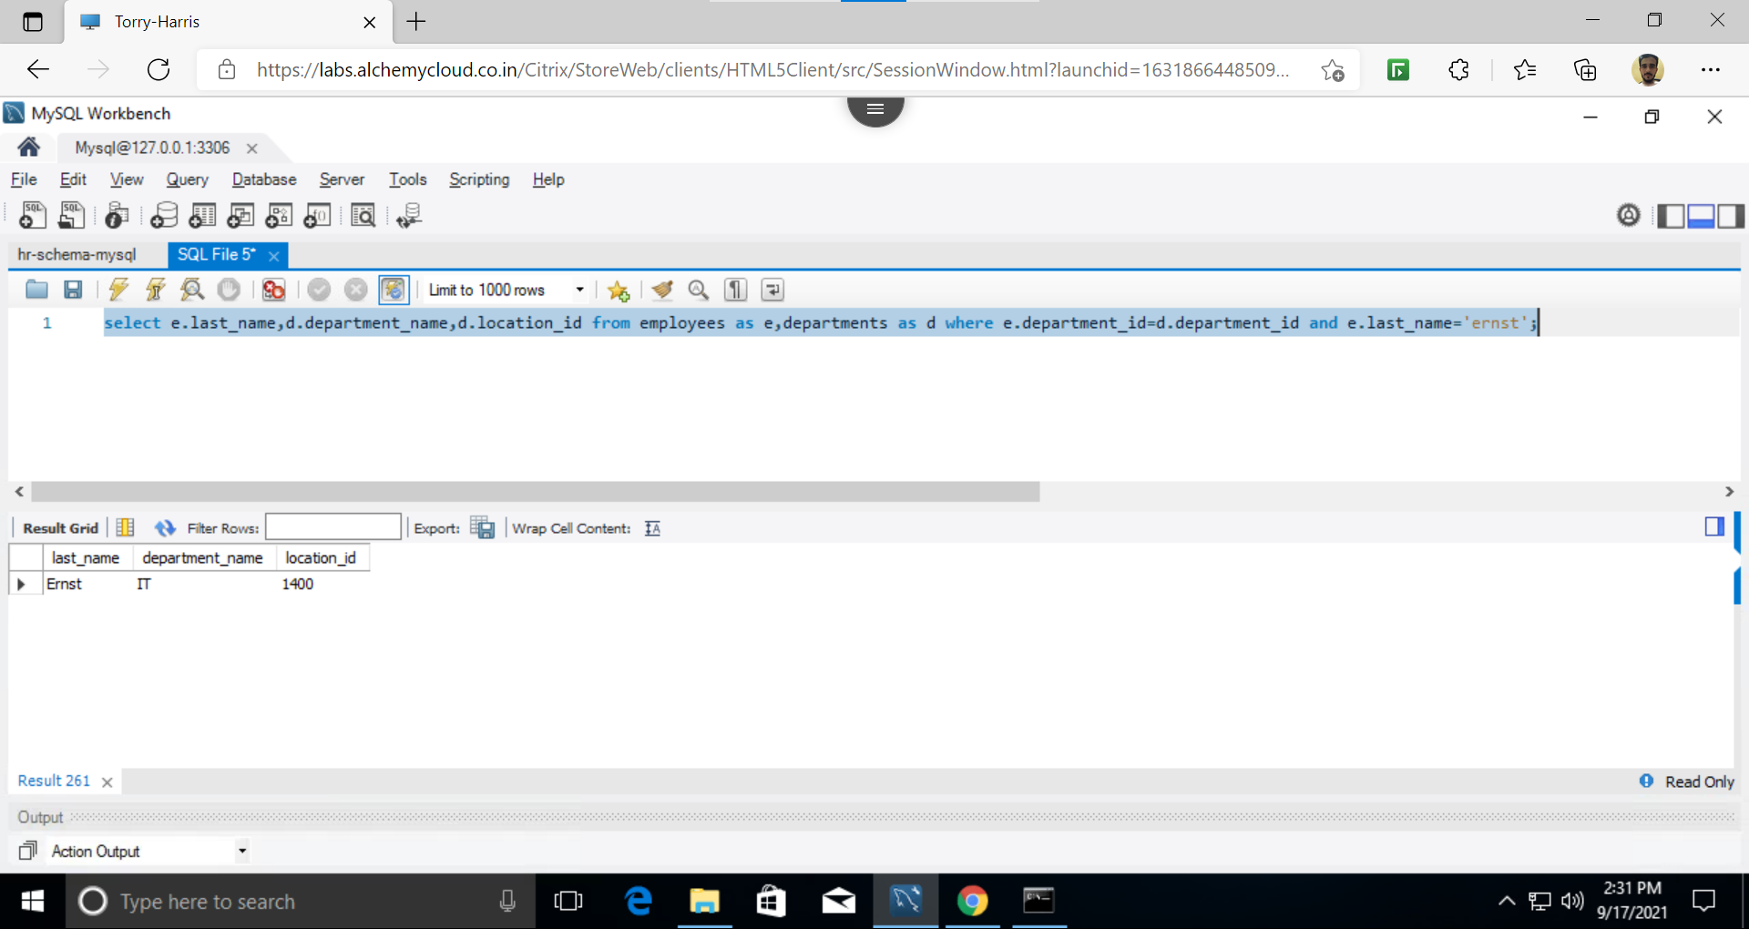

17.select e.first_name,d.department_id,l.location_id,l.city from employees as e,departments as d,locations as l where e.department_id=d.department_id and d.location_id=l.location_id and l.city=’tokyo’;

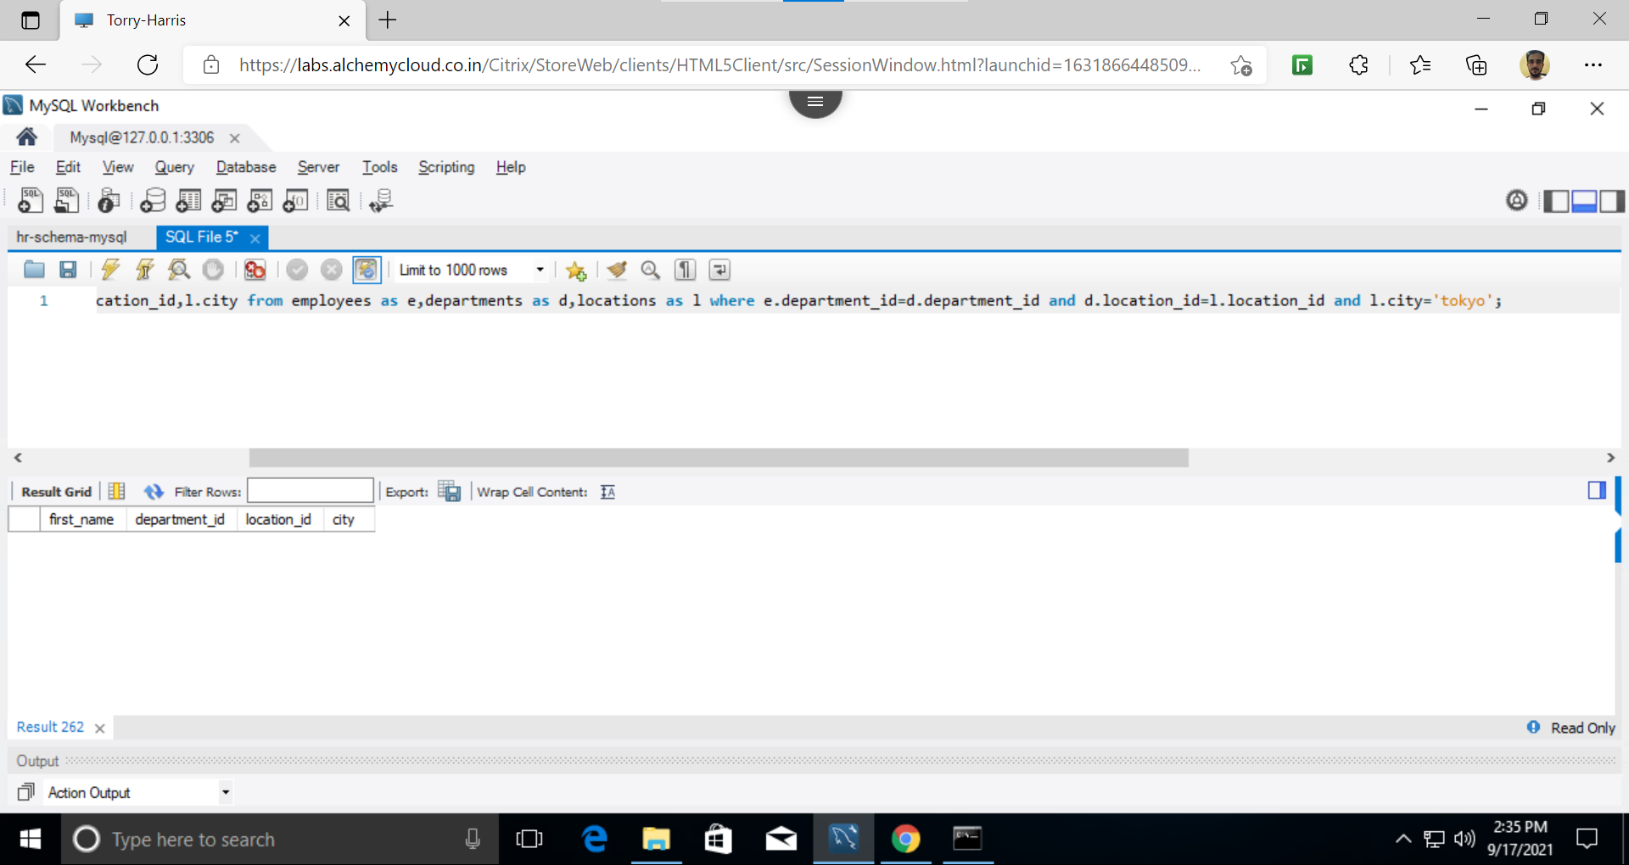

18.select first_name,last_name,max(salary) from employees;

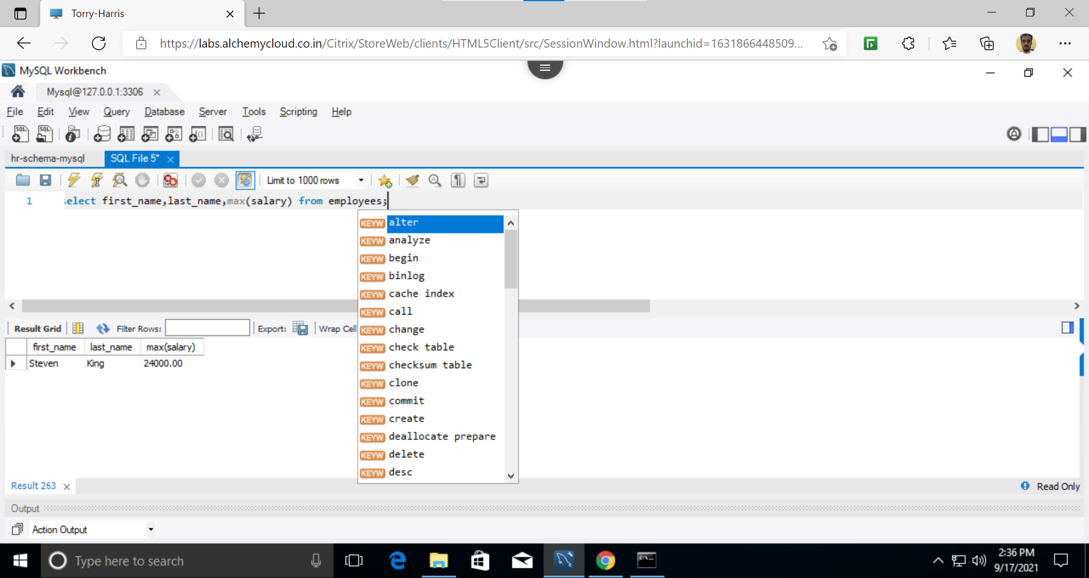

19.select first_name,last_name,department_id,min(salary) from employees group by department_id;

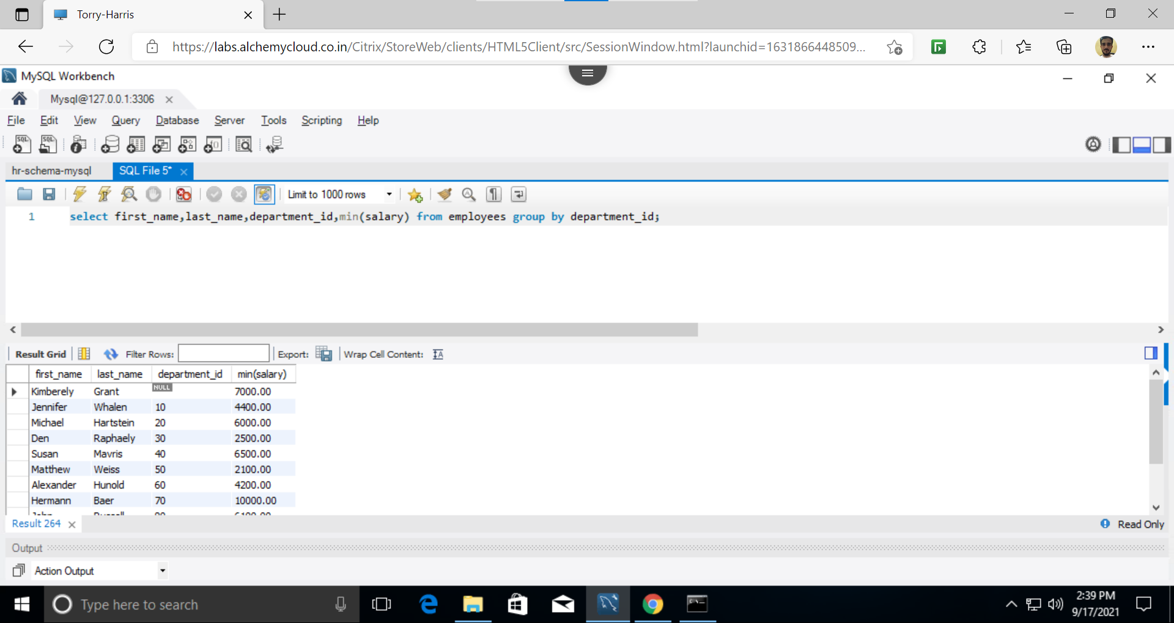

20. Select employees.first_name,employees.last_name,employees.job_id,jobs.job_title from employees inner join jobs on employees.job_id=jobs.job_id;

